

Functional Area: 38 Review MTM Profile

Screen Specifications

Document History
Version | Date | Description | Name
0.1 | 15/02/2006 | Initial draft | Nicholas Cole
0.2 | 19/02/2006 | Reviewed with the business.  Screens for Login, Locate Customer and Delete MTM account have been baseline. | Nicholas Cole
0.3 | 19/02/2006 | View Audit History Added | Nicholas Cole
0.4 | 13/03/2006 | Major Updates – MTM Profile statuses removed, send security questions removed, permanent and temporary lock added. Tabs added to view personal details, associated billing accounts and associate a new account. | Nicholas Cole
0.5 | 14/03/2006 | Review with ST. Minor updates. | Nicholas Cole
0.6 | 19/03/2006 | OTP Bypass has changed – Now 3 levels. Change business role has been removed.  Security Questions and answers will be sent via SMS and E-Mail. Send MTM password removed. | Nicholas Cole
0.7 | 28/03/2006 | Minor updates after review with the Business (TW & EL)  Baselined | Nicholas Cole

1.1.1 Screens 3
1.1.1.1 Screen – Review MTM Profile (MTM Account Details Tab) 3
1.1.1.2 Screen – Review MTM Profile (Review Association Tab) 8
1.1.1.3 Screen – Review MTM Profile (Association a new billing account Tab) 11
1.1.1.4 Domain Model 13

Screens

Screen – Review MTM Profile (MTM Account Details Tab)

This screen will be displayed when a MTM account has been successfully located.

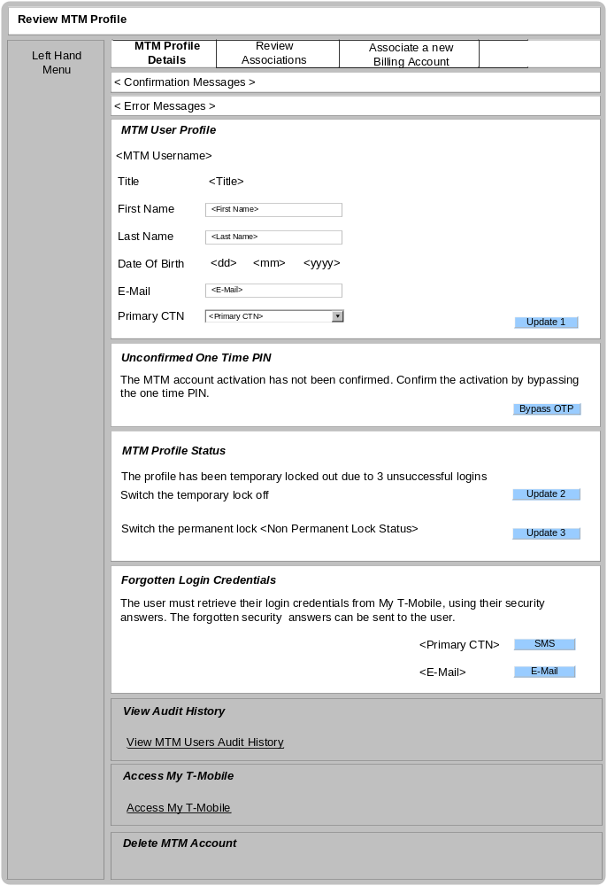

Business Logic Content

Name | Type | Description/Condition
Review MTM Profile | Screen Title | The title of the screen
Left Hand Menu Tile
Described within the locate MTM screen specification.
Tabs
MTM Profile Details Tab – Always default tab on entry.
This tab will allow the user to manage information for the MTM profile.
Review Associations Tab – A tab will be displayed when there is an associated billing account to the MTM profile. For some users, there won’t be an association.
This tab will allow the user to manage the existing billing account associations.
Associate a New Billing Account Tab – Only 1 instance of this tab will be displayed at any given time.
This Tab will allow the user to associate a new billing account to the MTM profile
Confirmation Messages | Dynamic Text | The confirmation Messages will be displayed when a successful update occurs;  If the MTM User Profile details are successfully updated:  Message = “MTM User Profile details successfully updated.”  If the OTP has been successfully bypassed:  Message = “OTP has been successfully bypassed”  If the temporary lock is successfully updated:  Message = “Temporary lock has been removed.”  If the permanent lock is successfully updated:  Message = “Permanent lock has been successfully updated.”  If the forgotten security answers have been successfully sent:  Message = “The forgotten password have been successful sent.”  If the account association has been successfully removed:  Message = “The account association has been successfully removed.”
Error Messages | Dynamic Text | The Error Messages will be displayed if any of the validation rules are not met.  If First Name is null or incorrect;  Error Message = “Please enter a valid First Name.”  If Last Name is null or incorrect;  Error Message = “Please enter a valid Last Name.”  If E-Mail is null or incorrect;  Error Message = “Please enter a valid E-Mail.”  If the temporary lock update is unsuccessful;  Error Message = “The temporary lock update has failed, please try again later.”  If the permanent lock update is unsuccessful;  Error Message = “The permanent lock update has failed, please try again later.”  If back end system is unavailable;  Error Message = “There has been a technical error, please try again later.”
MTM User Profile
This tile is always displayed. This will allow the user to manage the MTM users personal details

<MTM Username> | Dynamic Text | The MTM username of the located MTM account.
<Title> | Dynamic Text | Show the selected Title of the MTM user.
<First name> | Data entry field and dynamic text | Show the first name of the MTM User on entry  View common validation document for validation rules on this field.
<Last name> | Data entry field and dynamic text | Show the last name of the MTM User on entry  View common validation document for validation rules on this field.
Date of Birth <dd> | Dynamic Text | The day of the date of birth of the MTM User.
Date of Birth <mm> | Dynamic Text | The month of the date of birth of the MTM User.
Date of Birth <yyyy> | Dynamic Text | The year of the date of birth of the MTM User.
E-Mail | Data entry field and dynamic text | Show the e-mail address of the MTM User on entry  View common validation document for validation rules on this field.
Primary CTN | Drop Down List | Show the primary CTN of the MTM account on entry.  If there isn’t a primary CTN then the default = ‘No Primary CTN’  The drop down list will contain all the available primary CTNs within all the Ban’s associated to the MTM account and Business Role  The list should not contain any CTN’s which are the primary CTNs on another MTM account.  The drop down list should always display the option of ‘No Primary CTN’
Unconfirmed One Time PIN
This tile is only displayed if there is an unconfirmed one time PIN for the MTM account activation. This area will allow the user to bypass the OTP.

MTM Profile Status
This tile is always displayed. This will allow the user to manage the temporary and permanent locks on the MTM account.

Temporary Lock | Dynamic Text and link | This area will only be displayed if a temporary lock exists on the MTM account.
<Non permanent lock status> | Dynamic Text | The non status of the permanent lock on the MTM account.  Display options – ‘On’ or ‘Off’  This area is always displayed.
Forgotten Login Credentials
This tile is always displayed. This will allow the CSA to support the MTM user with forgotten login credentials. The 3 security answers will be sent to the user via e-mail or SMS.
Only one of the E-Mail or SMS options should be displayed at any given time.

<E-Mail> | Dynamic Text and link | Only shown if the user does not have a Primary CTN.  The e-mail address of the MTM profile on entry
<Primary CTN> | Dynamic Text and link | Only displayed is the user has a primary CTN.  The primary CTN of the MTM profile.
View Audit History
This tile is always displayed. This will allow the user to view the MTM accounts audit history.

Access My T-Mobile
This tile is always displayed. This area will allow the CSA’s to access the customer MTM account.
Delete MTM Account Tile
This tile is always displayed. See the delete MTM account screen specification for tile behaviour.

Links
Name | Destination | Description/Condition
Update 1 | Review MTM Profile (MTM Account Details Tab) | The Review MTM profile screen will be reloaded with either a confirmation message or error message. This link will update the personal details of the MTM account.  When the screen reloads, it must reflect the changes made by this link.
Bypass OTP | Review MTM Profile (MTM Account Details Tab) | The Review MTM profile screen will be reloaded with either a confirmation message or error message. This link will confirm the OTP for the associated MTM account and remove the temporary lock (if one exists).  When the screen reloads, it must reflect the changes made by this link.
Update 2 | Review MTM Profile (MTM Account Details Tab) | The Review MTM profile screen will be reloaded with either a confirmation message or error message. This link will turn off the temporary lock on the MTM account  When the screen reloads, it must reflect the changes made by this link.
Update 3 | Review MTM Profile (MTM Account Details Tab) | The Review MTM profile screen will be reloaded with either a confirmation message or error message. This link will turn on/off the permanent lock on the MTM account  When the screen reloads, it must reflect the changes made by this link.
SMS | Review MTM Profile (MTM Account Details Tab) | The Review MTM profile screen will be reloaded with either a confirmation message or error message.  This link will SMS the security answers.
E-Mail | Review MTM Profile (MTM Account Details Tab) | The Review MTM profile screen will be reloaded with either a confirmation message or error message.  This link will e-mail the security answers.
View Audit History | View Audit History Screen | The view audit history screen will be displayed. This link will show the MTM accounts audit history.
MTM Profile Details Tab | Review MTM Profile (MTM Profile Details Tab) | The Review MTM profile screen will be reloaded showing the selected tab.
Review Association Tab | Review MTM Profile (Review Association Tab) | The Review MTM profile screen will be reloaded showing the selected tab.
Associate a New Billing Account Tab | Review MTM Profile (Associate a New Billing Account Tab) | The Review MTM profile screen will be reloaded showing the selected tab.

Validation
Name | State / Response
MTM User Profile Details | If an update is submitted and the field validation fails, an error message must be displayed.

Screen – Review MTM Profile (Review Association Tab)

This screen will be displayed when the user selects to review the associated billing account.

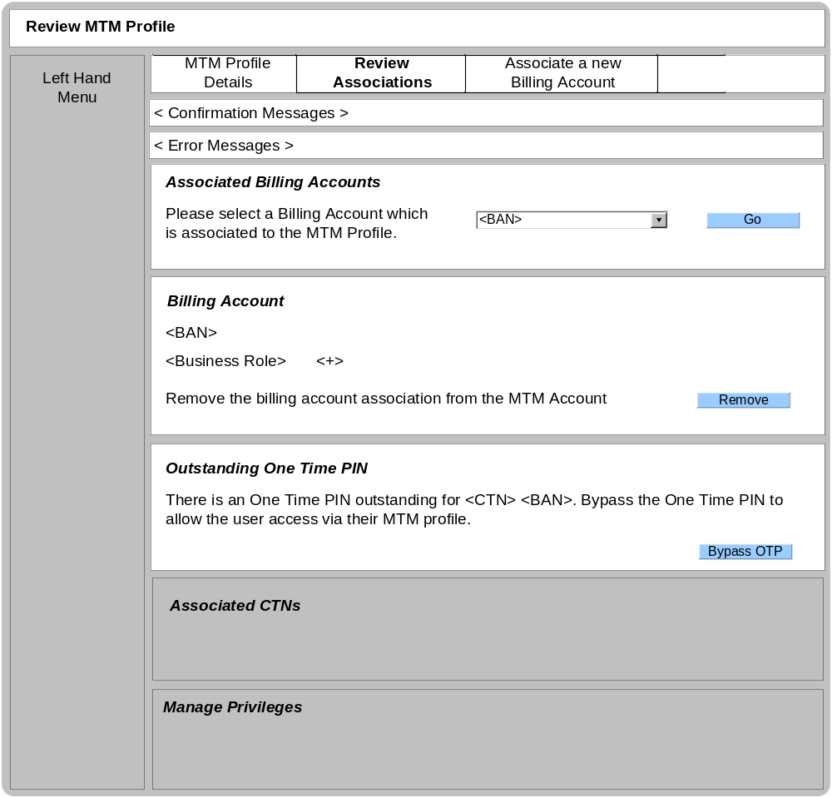

Business Logic Content

Name | Type | Description/Condition
Review MTM Profile | Screen Title | The title of the screen
Left Hand Menu Tile
Described within the locate MTM screen specification.
Tabs
MTM Profile Details Tab – Always default tab on entry.
This tab will allow the user to manage information for the MTM profile.
Review Associations Tab – A tab will be displayed when there is an associated billing account to the MTM profile. For some users, there won’t be an association.
This tab will allow the user to manage the existing billing account associations.
Associate a New Billing Account Tab – Only 1 instance of this tab will be displayed at any given time.
This Tab will allow the user to associate a new billing account to the MTM profile
Confirmation Messages | Dynamic Text | The confirmation Messages will be displayed when a successful update occurs;  If the OTP is successfully bypassed:  Message = “The One Time PIN has been confirmed.”  If the remove BAN association is successful  Message = “The BAN association has been successfully removed.”
Error Messages | Dynamic Text | The Error Messages will be displayed if any of the validation rules are not met.  If the OTP bypass was unsuccessful  Message = “The One Time PIN bypass has been unsuccessful, please try again later.”  If the remove BAN association was unsuccessful  Message = “The remove BAN association has been unsuccessful, please try again later.”
Associated Billing Account
This tile is always displayed. This area will allow the CSA to select a Billing account (associated to a MTM profile) to manage.

<BAN> | Dynamic Text or Dropdown List | If only 1 BAN associated, then display the Billing Account number as dynamic text.  If > 1 BAN associated, then display all the billing account numbers in a drop down list.  Default BAN – the BAN closest to zero.
T-Mobile Billing Account Association
This tile is always displayed. This tile will indicate the role the MTM user has on the associated billing account.
<BAN> | Dynamic Text | The selected billing account number.  Always displayed
<Business Role> | Dynamic Text | The business role (account holder/subscriber ect) on the associated MTM account.  Always displayed
<+> | Dynamic Text | This indicates if the business role has had their privilege set modified
Associated CTN’s
This tile is only displayed if the OTP has been confirmed. See Review Associated T-Mobile Accounts screen specification for tile behaviour.
Manage Privileges
This tile is only displayed if the OTP has been confirmed. See Review Privileges screen specification for tile behaviour.
Unconfirmed One Time PIN
This tile is only displayed if there is an unconfirmed one time PIN. This area will allow the user to bypass the OTP.

<BAN> | Dynamic Text | The billing account number which has been associated and has an outstanding OTP.
<CTN> | Dynamic Text | The CTN which has been associated and has an outstanding OTP

Links
Name | Destination | Description/Condition
Go | Review MTM Profile (Review Associations Tab) | The Review MTM profile screen will be reloaded with the selected Billing Account Number. All details relating to the billing account will be displayed in the lower tiles.
Bypass OTP | Review MTM Profile (Review Association Tab) | The Review MTM profile screen will be reloaded with either a confirmation message or error message. This link will confirm the OTP for the associated MTM account and remove the temporary lock (if one exists).  When the screen reloads, it must reflect the changes made by this link.
Remove | Review MTM Profile (MTM Profile Details Tab) | 1 Associated Ban  The Review MTM profile screen (MTM Account Details Tab) will be loaded with a confirmation message.  This link will remove the BAN association to the MTM profile.
Remove | Review MTM Profile (MTM Profile Details Tab) | > 1 Associated BAN  The Review MTM profile screen (Review Association Tab) will be loaded with a confirmation message.  This link will remove the BAN association to the MTM profile.
Remove | Review MTM Profile (Review Association Tab) | The Review MTM profile screen (Review Associations Tab) will be loaded with an error message.  When this error occurs, the BAN association will not be removed.
MTM Profile Details Tab | Review MTM Profile (MTM Profile Details Tab) | The Review MTM profile screen will be reloaded showing the selected tab.
Review Association Tab | Review MTM Profile (Review Association Tab) | The Review MTM profile screen will be reloaded showing the selected tab.
Associate a New Billing Account Tab | Review MTM Profile (Associate a New Billing Account Tab) | The Review MTM profile screen will be reloaded showing the selected tab.

Validation
None

Screen – Review MTM Profile (Association a new billing account Tab)

This screen will be displayed when the user selects to associate a new billing account.

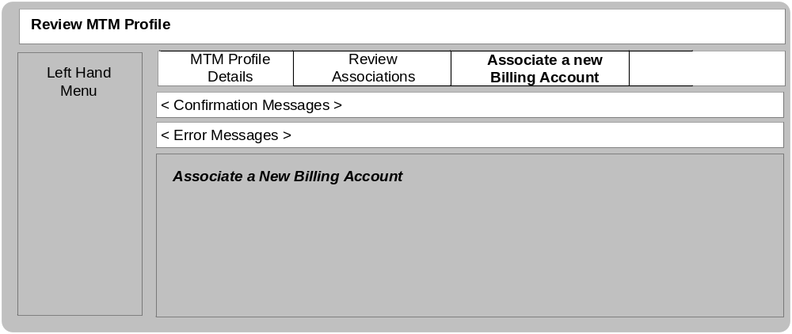

Business Logic Content

Name | Type | Description/Condition
Review MTM Profile | Screen Title | The title of the screen
Left Hand Menu Tile
Described within the locate MTM screen specification.
Tabs
MTM Profile Details Tab – Always default tab on entry.
This tab will allow the user to manage information for the MTM profile.
Review Associations Tab – A tab will be displayed when there is an associated billing account to the MTM profile. For some users, there won’t be an association.
This tab will allow the user to manage the existing billing account associations.
Associate a New Billing Account Tab – Only 1 instance of this tab will be displayed at any given time.
This Tab will allow the user to associate a new billing account to the MTM profile
Confirmation Messages | Dynamic Text | The confirmation Messages will be displayed when a successful update occurs;  TBD
Error Messages | Dynamic Text | The Error Messages will be displayed if any of the validation rules are not met.  TBD
Associate a new billing account
This tile is always displayed. This tile will allow the user to associate a new billing account to the MTM user profile. See Associate MTM Account screen specification for behaviour.

Links
Name | Destination | Description/Condition
MTM Profile Details Tab | Review MTM Profile (MTM Profile Details Tab) | The Review MTM profile screen will be reloaded showing the selected tab.
Review Association Tab | Review MTM Profile (Review Association Tab) | The Review MTM profile screen will be reloaded showing the selected tab.
Associate a New Billing Account Tab | Review MTM Profile (Associate a New Billing Account Tab) | The Review MTM profile screen will be reloaded showing the selected tab.

Validation
None

Domain Model

Field | Domain Model Name
MTM Username | MTMUser.LocalUser.userId
Title | MTMUser.Person.title
First Name | MTMUser.Person.firstName
Last Name | MTMUser.Person.lastName
Date of birth | MTMUser.Person.dateOfBirth
E-mail | MTMUser.Person.email
Primary CTN | MTMUser.MTMUserProfile.UserProfileMobile.isCommunicationCTN
Non Permanent Lock Status | Calculation – Opposite status to;  MTMUser.LocalUser.isAccountLocked
Temporary Lock | MTMUser.temporaryLockTimeOut
<E-Mail> | MTMUser.Person.email
<Primary CTN> | MTMUser.MTMUserProfile.UserProfileMobile.isCommunicationCTN
OTP (Profile Activation) | MTMUser.OTP.oneTimeSecurityPIN
Associated Billing Accounts  <BAN> | MTMUser.MTMUserProfile.BillingAccount.accountnumber
BAN | MTMUser.MTMUserProfile.BillingAccount.accountnumber
Business Role | MTMUser.MTMUserProfile.BusinessRole.MTMRole
<+> | MTMUser.MTMUserProfile.UserPrivilege
<CTN> | MTMUser.MTMUserProfile.UserProfileMobile.Mobile.ctn
<BAN> | MTMUser.MTMUserProfile.BillingAccount.accountnumber
OTP (BAN Activation) | MTMUser.MTMUserProfile.OTP.oneTimeSecurityPIN
OTP (CTN Activation) | MTMUser.MTMUserProfile.UserProfileMobile.OTP.oneTimeSecurityPIN

Methods | Descriptions
Update Personal Details | Updates the changes made to the MTM personal details.  Impacted Parameters  MTMUser.Person.firstName  MTMUser.Person.lastName  MTMUser.Person.email  MTMUser.MTMUserProfile.UserProfileMobile.isCommunicationCTN
Switch Off Temporary Lock | Removes the temporary lock from the MTM account  Impacts  MTMUser.temporaryLockTimeOut – set to null
Update Permanent Lock | Changes the status of the Permanent lock on the MTM account  Impacts  MTMUser.LocalUser.isAccountLocked – set to on or off
E-Mail Security Answers | Sends the forgotten security answers to the user via E-Mail. Send all 3 answers.  Impacts  Get MTMUser.SecurityAnswer.response and insert/send in a e-mail
SMS Security Answers | Sends the forgotten security answers to the user via SMS. Send all 3 answers.  Impacts  Get MTMUser.SecurityAnswer.response and insert/send in a SMS.
OTP (Profile Activation) | Bypass the OTP data for Profile Activation.  Remove;  MTMUser.OTP.otpTimestamp  MTMUser.OTP.oneTimeSecurityPIN  MTMUser.OTP.otpMethodDispatched  MTMUser.OTP.temporaryLockTimeOut
Fetch Associated BAN | Fetch the associated BAN  Return  MTMUser.MTMUserProfile.BillingAccount.accountnumber  MTMUser.MTMUserProfile.BusinessRole.MTMRole  MTMUser.MTMUserProfile.UserPrivilege  MTMUser.MTMUserProfile.UserProfileMobile.Mobile.ctn  MTMUser.MTMUserProfile.BillingAccount.accountnumber  MTMUser.MTMUserProfile.OTP.oneTimeSecurityPIN (If applicable)  MTMUser.MTMUserProfile.UserProfileMobile.OTP.oneTimeSecurityPIN (If applicable)
Remove BAN association | Removes the associated BAN from the MTM account  MTMUserProfile - Destroy
OTP (BAN Activation) | Bypass the OTP for BAN Activation.  Remove;  MTMUser.MTMUserProfile.OTP.otpTimestamp  MTMUser.MTMUserProfile.OTP.oneTimeSecurityPIN  MTMUser.MTMUserProfile.OTP.otpMethodDispatched  MTMUser.MTMUserProfile.OTP.temporaryLockTimeOut
OTP (CTN Activation) | Bypass the OTP for CTN Activation.  Remove;  MTMUser.MTMUserProfile.UserProfileMobile.OTP.otpTimestamp  MTMUser.MTMUserProfile.UserProfileMobile.OTP.oneTimeSecurityPIN  MTMUser.MTMUserProfile.UserProfileMobile.OTP.otpMethodDispatched  MTMUser.MTMUserProfile.UserProfileMobile.OTP.temporaryLockTimeOut

